Experiment 10

Aim of the experiment: to understand and implement the concept of group by clause using SQL.

Program:

SQL> select deptid,sum(salary) from employee group by deptid ;

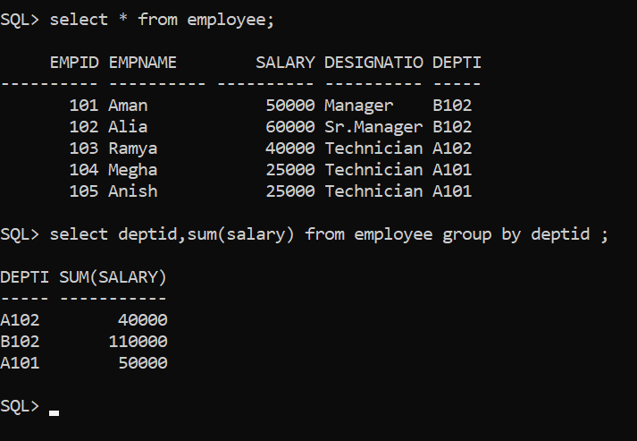

SQL> select dept_name from employee,department where employee.deptid=department.deptid group by dept_name;

DEPT_NAME

----------

System

Sales

Marketing

SQL> select dept_name,avg(salary) from employee,department where employee.deptid=department.deptid group by dept_name;

DEPT_NAME AVG(SALARY)

---------- -----------

System 25000

Sales 40000

Marketing 55000

